Sb₂Se₃ single-layer 1064nm-optical limiter at 1.5 Million Cycles
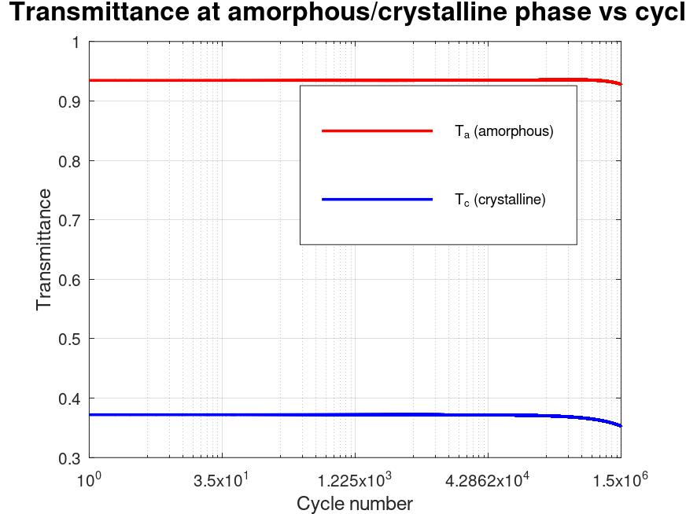 | 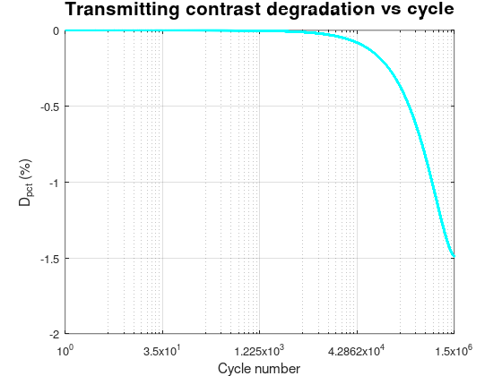
(a) | (b)
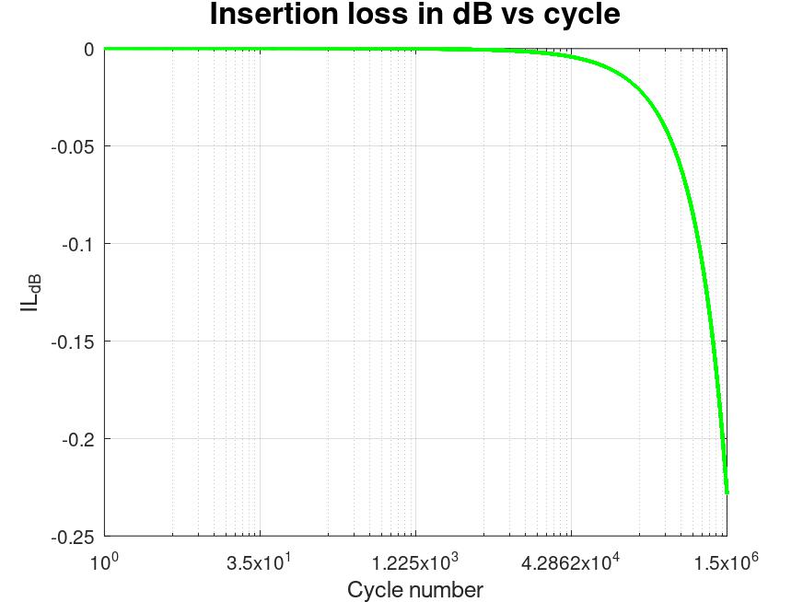
(c)
Figure X. Endurance performance of the single-layer Sb₂Se₃ resonant optical limiter at 1064 nm after 1.5×10⁶ thermo-optical cycles. (a) On-resonance transmittance of the device when Sb₂Se₃ is in the amorphous and crystalline states as a function of cycle number. (b) Percentage transmitting-contrast degradation relative to the initial value as a function of cycle number. (c) Insertion loss in the high-transmission (amorphous) state, expressed in dB, as a function of cycle number.

[(Sb₂Se₃)/2|MgF₂|(Sb₂Se₃)/2]⁴ 1064nm-optical limiter
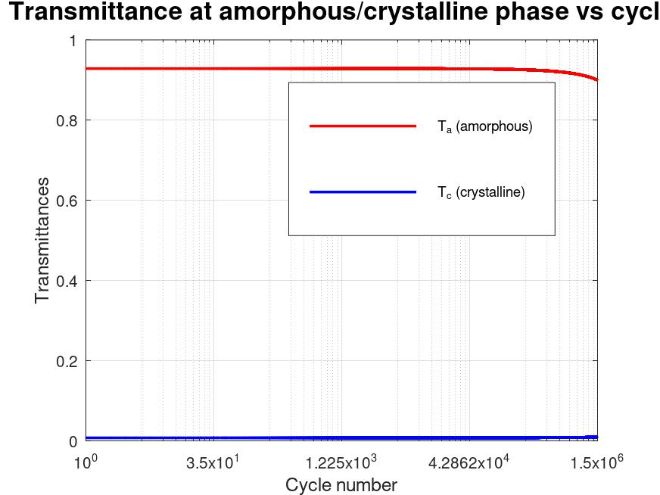 | 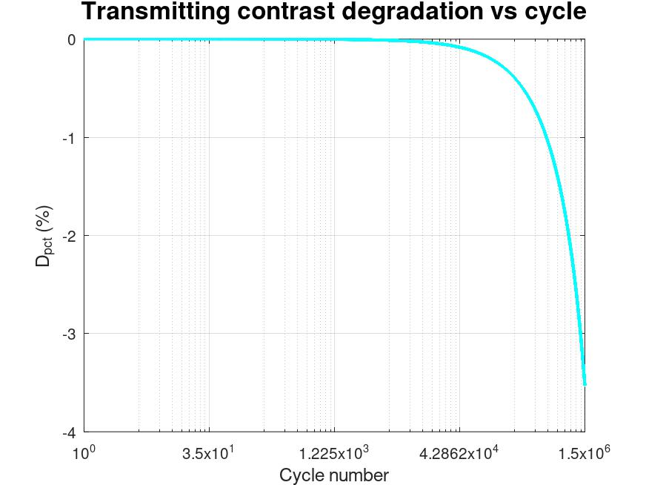
(a) | (b)
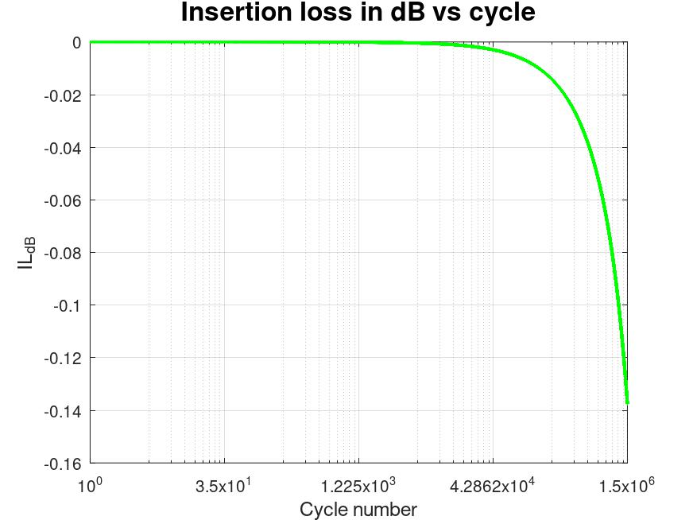
(c)
Figure Y. Endurance performance of the 9-layers-edge-filter resonant optical limiter at 1064 nm after 1.5×10⁶ thermo-optical cycles. (a) On-resonance transmittance of the device when Sb₂Se₃ is in the amorphous and crystalline states as a function of cycle number. (b) Percentage transmitting-contrast degradation relative to the initial value as a function of cycle number. (c) Insertion loss in the high-transmission (amorphous) state, expressed in dB, as a function of cycle number.

[(Sb₂Se₃)/2|MgF₂|(Sb₂Se₃)/2]⁵ 1064nm-optical limiter
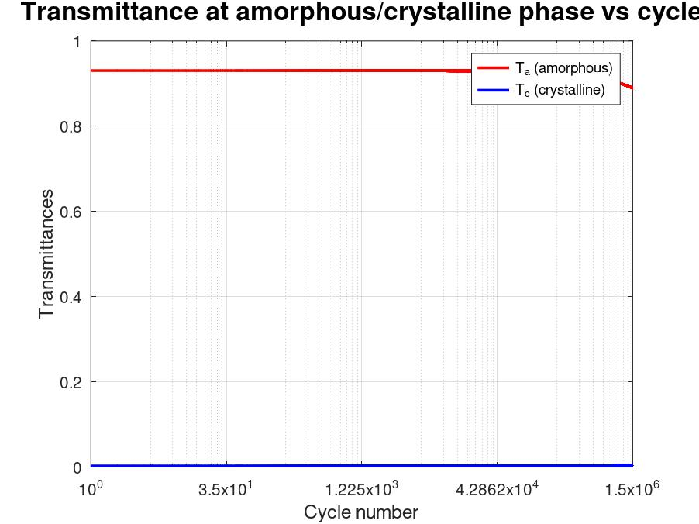 | 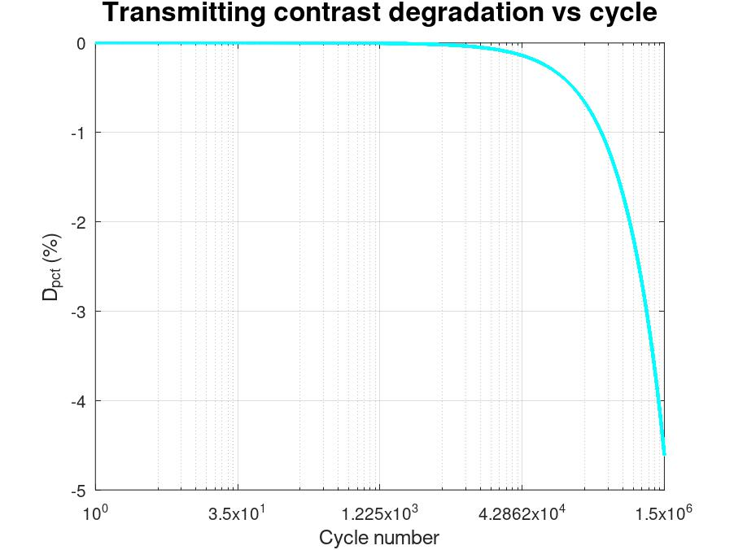
(a) | (b)
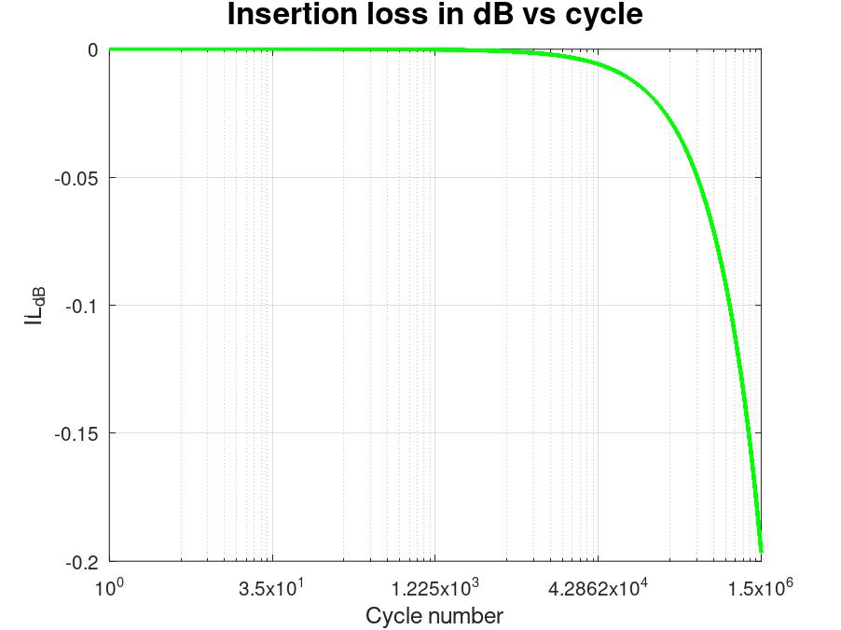
(c)
Figure Z. Endurance performance of the 11-layers-edge-filter resonant optical limiter at 1064 nm after 1.5×10⁶ thermo-optical cycles. (a) On-resonance transmittance of the device when Sb₂Se₃ is in the amorphous and crystalline states as a function of cycle number. (b) Percentage transmitting-contrast degradation relative to the initial value as a function of cycle number. (c) Insertion loss in the high-transmission (amorphous) state, expressed in dB, as a function of cycle number.

Endurance testing at 1064 nm demonstrates that all three resonant optical limiter architectures, e.g. single Sb₂Se₃ layer, 9‑layer edge filter, and 11‑layer edge filter, remain operational up to 1.5×10⁶ thermo‑optical cycles, with design‑dependent degradation of their transmission metrics. For the single‑layer device, the amorphous‑state transmittance stays close to its initial high value, while the crystalline‑state transmittance changes only modestly, indicating that a simple Fabry–Pérot stack is relatively robust against endurance‑induced index drift and loss in Sb₂Se₃. The corresponding percentage contrast degradation and insertion loss in the amorphous state increase slowly, confirming that the single layer can tolerate repeated switching with only minor deterioration of limiting contrast and transparency.
In the 9‑layer edge‑filter cavity, the amorphous transmittance also remains high, but the crystalline‑state transmittance exhibits a more pronounced evolution with cycling, reflecting the higher sensitivity of the resonant edge to small changes in the Sb₂Se₃ optical constants. Here, the percentage contrast degradation is noticeably larger than in the single layer, and the insertion loss of the amorphous state increases more rapidly, which is consistent with stronger field confinement and longer effective optical path within the lossy material.
The 11‑layer edge filter further accentuates these trends: its crystalline‑state transmittance and contrast metrics change most strongly with cycle number, while the amorphous‑state insertion loss shows the largest cumulative increase among the three structures. These results highlight the expected trade‑off between high initial limiting performance and endurance robustness: increasing cavity complexity and Q‑factor enhances on‑resonance modulation but also amplifies the impact of endurance‑induced drift and loss in Sb₂Se₃, so simpler stacks provide better long‑term stability whereas more resonant designs require tighter control of material and thermal cycling conditions.

